**Partner & Year wise Analysis of Financial Data**

Shivam Patel, Satnam Jaggi Kaur, Yash Singh, Trusha Sonawane  
ALY6070   
Prof. John Wilder   
2024/03/25

**Abstract**

This report provides an in-depth analysis of financial and operational data using advanced data visualization techniques to support strategic decision-making. The study examines expenditure patterns across key sectors, including Education, Food, Health, Community, and Livelihood, over a three-year period (2022-2024). By utilizing dashboards and a variety of visual tools such as bar charts, pie charts, and line graphs, the report highlights trends in funding distribution and cost allocation among different partners. The findings indicate significant shifts in investment priorities, with Education receiving the highest allocation, Food expenditures experiencing fluctuations, and Livelihood funding showing a decline. Additionally, the report evaluates financial performance by comparing actual expenditures with budgeted and forecasted amounts, emphasizing the importance of efficient budget management and resource optimization. By applying best practices in data storytelling and visualization, this report equips stakeholders with actionable insights that enhance financial planning, improve resource distribution, and ensure long-term financial sustainability.

**Part I**

**Distribution of Each Partner's Cost by Category**

**Introduction**

**This research examines how three partners A, B and C distribute their funds between Food, Livelihoods, Education, Community and Health categories. Each project category consists of Food and Livelihoods and Education together with Health and Community. The cost distribution percentages for each category among Partners A B C are presented through stacked bar charts.**

**Analysis**

|  |
| --- |
| **[Distribution of each partner's cost by category](https://app.powerbi.com/MobileRedirect.html?action=OpenReport&reportObjectId=8a42db3c-56d1-4c36-9d92-3411913689c6&ctid=a8eec281-aaa3-4dae-ac9b-9a398b9215e7&reportPage=ac73268bd12e10b7464a&pbi_source=copyvisualimage)** |

**Partner A:**

* **The category with the biggest portion of budget goes to Livelihoods whose allocation reaches 39.99%.**
* **Education stands as the second most substantial cost aspect consuming 35.67% of the total expenses.**
* **The community expenses represent 32.97 percent of the total cost structure.**
* **Food receives 18.90% from the total funds which ranks as the lowest among all contributors.**
* **The cost expenditure for health care sits beneath the amount dedicated to other categories.**

**Partner B:**

* **Community expenses reach 47.15% in terms of total allocation.**
* **Health follows closely at 44.87%.**
* **Education uses 30.98% of public spending within the institution.**
* **The expenses attributed to livelihoods represent 30.52 percent of the budget.**
* **The share of food expenditure has seen a slight increase to become 30.52% of the total cost.**

**Partner C:**

* **The Food category receives the biggest share (65.32%) of total expenses which establishes its leading position.**
* **Livelihoods account for 29.49% of expenditures.**
* **The expenses related to education occupy 33.35% of the budget distribution.**
* **Community receives 19.88% of the funding.**
* **The expenses dedicated to health care tap 45.79% of the total budget.**

**Key Findings**

* **Food expenses take up the largest share in spending for Partner C compared to his other partners.**
* **The cost distribution is even throughout the activities, yet Partner A dedicates its maximum financing to Livelihoods.**
* **The community and health expenses receive the largest allocation from partner B who also increases his spending on food services.**
* **The three partners dedicate significant funding to health-related expenses because health issues are essential budget concerns.**

**Conclusion**

**The report shows a pattern of budget allocation differences because Partner C dedicates most money to Food while Partner A places essential emphasis on Livelihoods and Partner B spends the majority of funds on both Community and Health. Additional knowledge about these spending allocations assists organizations with making better investment decisions and reallocations to distribute funds properly across all areas.**

**Partner Financial Performance: Budget, Forecast, and Actual Spending**

**Introduction**

The report evaluates partner financial performance through data analysis between current Year-to-Date (YTD) Actuals and both YTD Budget and YTD Forecasted expenditures for partners A, B, and C. The percentage distribution of total expenditure serves as the data representation.

**Analysis**

**Partner A**

* YTD Actuals: 12.94%
* YTD Budget: 21.03%
* YTD Forecast: 13.77%
* Actual spending amounts to only 12.94% of the budgeted 21.03%.
* The forecasted expenditure amount (13.77%) reveals slight variation from actual spending results.
* The results indicate that Partner A uses fewer funds compared to its budgeted amount.

**Partner B**

* YTD Actuals: 14.29%
* YTD Budget: 14.29%
* YTD Forecast: 10.05%
* The actual costs match precisely with the established budget.
* Future projections suggest the organization will decrease spending levels from actual amounts by 10.05% throughout the budget period.
* The budget management at Partner B indicates success through its financial metrics.

**Partner C**

* YTD Actuals: 2.25%
* YTD Budget: 4.13%
* YTD Forecast: 7.22%
* Actual costs remain well below the forecasted and budgeted figures since they amount to 2.25% compared to 4.13% and 7.22% respectively.
* Upcoming expenditures exceed current spending in the forecast thus indicating unidentified future payments.
* The present financial activities at Partner C seem to face possible scheduling challenges.

**Key Findings**

* Partner A currently spends under its budgetary target but the projected values suggest upcoming expenses will exceed the budget.
* The current budget usage by Partner B remains efficient but upcoming expenses predict a slight decrease in spending levels.
* Partner C shows the smallest actual spending in relation to both its budget and forecast and this suggests possible delay or insufficient utilization of funds.

**Conclusion**

* Partner A must determine the reasons behind non-utilized budgeted funds and evaluate any necessary changes to spending.
* The current budget of Partner B demonstrates a successful outcome, but the company needs to watch future spending to prevent unexpected budget decreases.
* Partner C needs to examine delayed spending patterns then use actual patterns to adjust upcoming financial predictions for better accuracy.

**Direct Program Cost, Operational Cost, and Total Cost**

**Introduction**

The Direct Program Cost, Operational Cost, and Total Cost visualization shows the breakdown of costs for three partners (A, B, and C) across three categories: Total Cost, Total Direct Program Cost, and Total Operational Cost. The aim is to assess the cost distribution among these partners and draw conclusions based on their spending patterns.

**Analysis**

**Partner A**

* Partner A has the greatest total cost, exceeding $150 million.
* The direct program cost is higher than the operational cost, although being much lower overall.
* Partner A's expenditure is primarily focused on program execution, not operating costs.

**Partner B**

* Partner B has the second-highest total cost, slightly below Partner A.
* Similar to Partner A, the direct program cost is higher than the operational cost, although both are very small compared to the total cost.
* The cost distribution indicates efficient spending on program execution.

**Partner C**

* Partner C has the lowest total cost of the three, under $100 million.
* The direct program and operating costs remain, but are far lower than the other two

partners.

* Partners A and B have larger activities and funding than this.

**Key Findings**

* Partner A has the largest overall expenditure, indicating a larger project scope or greater operational costs.
* Partner B follows closely with a similar spending pattern, focusing on program

expenditures over operations.

* Partner C has the lowest total cost, presumably due to their lower scale operation.
* Direct program expenditures are greater than operational costs across all partners, indicating a focus on project execution over administrative expenses.

**Conclusion**

The data reveals that all three partners spend the majority of their budget on direct program costs rather than operating expenses. Partner A leads in overall expenditure, followed by Partner B, and Partner C operates on a smaller scale. This information can aid in budget allocation decisions and the evaluation of partner efficiency in fund utilization.

**Quarterly Spending Trends**

**Introduction**

The visualization depicts the quarterly spending trends of three partners (A, B, and C) over four quarters: Quarter 4 (October to December), Quarter 3 (July to September), Quarter 2 (April to June), and Quarter 1 (January to March). Each partner's spending habits are reflected in a distinct hue. This report examines their spending patterns and key observations.

**Analysis**

**Partner A**

* Partner A spent the most in Q4, reaching a peak of almost $4 billion.
* In Quarter 3, spending decreased dramatically.
* Spending remained constant from Q2 to Q1, indicating a declining trend overall.

**Partner B**

* Partner B began with low spending in Q4.
* Their spending climbed significantly in the third quarter, reaching around $3 billion.
* Their expenditure decreased from Quarter 2 onwards, but marginally climbed in

Quarter 1.

**Partner C**

* Partner C experienced moderate spending rise from Q4 to Q2.
* In Quarter 2, their spending surpassed Partner A's.
* Q1 spending decreased somewhat but remained consistent compared to Partners A and B's dramatic changes.

**Key Findings**

* Partner A had the largest spending in Q4 but decreased significantly in Q3 and remained low.
* Partner B experienced a peak in Q3, followed by a slow drop.
* Partner C's growth was consistent until Quarter 2, with a modest fall in Quarter 1.
* Partner C has a reasonably consistent spending behaviour despite overall volatility among partners.

**Conclusion**

**Conclusion**

The spending patterns reveal different financial strategies among partners. Partner A's sharp drop indicates a potential budget cut or the completion of a large project. Partner B spent aggressively in the third quarter but then cut down. Partner C demonstrated a steady spending trend, resulting in the most reliable financial allocation. Further investigation may be required to determine the underlying causes of these spending patterns.

**Part II**

**Introduction**  
A comprehensive understanding of expenditure allocation across various categories is essential for informed financial planning and strategic decision-making. This section of the dashboard presents a detailed analysis of cost distributions in key areas such as Education, Food, Health, Community, and Livelihood over a three-year period (2022-2024), and is further simplified into two Dashboard for better and systematics understanding. Utilizing a range of visualization techniques, including stacked bar charts, pie charts, and line graphs, this analysis provides stakeholders with actionable insights into spending patterns. By identifying trends and variations in resource allocation, organizations can enhance budgetary efficiency and align financial strategies with organizational objectives.

**Dashboard Part 1: Financial Overview**

The objective of this dashboard was to provide a clear financial overview of total costs, operational expenditures, and direct program costs. The goal was to enable stakeholders to identify trends in spending over the years and evaluate cost allocation among different partners.

* **Bar Chart (Total Cost by Year):**

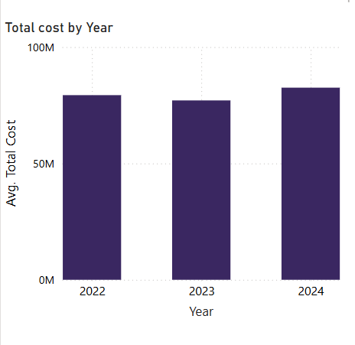

* **2022**: The bar for this year is slightly taller compared to 2023, indicating a higher average total cost.
* **2023**: A dip is observed, as the average total cost decreases slightly.
* **2024**: The average total cost rises again, surpassing 2023 but remaining slightly lower than 2022.
* Overall, the chart reveals a fluctuation in average total costs, with a decrease in 2023 followed by a modest increase in 2024.
* **Stacked Bar Chart (Operational Cost vs. Direct Program Cost):**

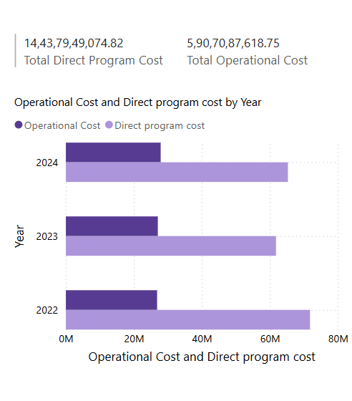

* **2022**:
* Operational Cost is roughly **20 million**.
* Direct Program Cost is approximately **60 million**, significantly surpassing Operational Cost.
* **2023**:
* Operational Cost remains unchanged at about **20 million**.
* Direct Program Cost drops to nearly **40 million**, marking a considerable decline compared to the previous year.
* **2024**:
* Operational Cost holds steady at around **20 million**.
* Direct Program Cost recovers slightly to about **50 million**, though it does not return to the 2022 level.
* **Total Direct Program Cost:** approximately **14.44 billion**.
* **Total Operational Cost:** about **5.91 billion**.
* This analysis highlights that while Operational Costs remain consistent over the years, Direct Program Costs exhibit noticeable fluctuations.
* **Pie Chart (Avg. Total Cost by Partner):**

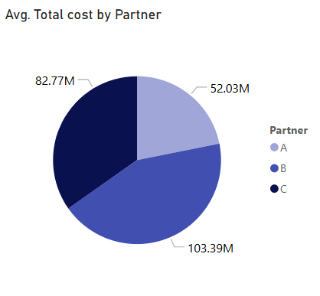

* **Partner A**: Represents an average total cost of **52.03M**, making it the partner with the lowest associated cost.
* **Partner B**: Accounts for the highest cost at **103.39M**, surpassing the other two significantly.
* **Partner C**: Falls in between with an average total cost of **82.77M**.
* The chart clearly illustrates that Partner B incurs the greatest cost, while Partner A is the most cost-efficient of the three. This distribution highlights potential areas for analysis, such as identifying what drives Partner B’s higher costs or exploring ways to optimize expenses across all partners.

**Dashboard Part 2: Category-Based Expenditure Analysis**

The objective of this section was to analyse cost allocations across different categories, such as Education, Food, Health, Community, and Livelihood, over a span of three years (2022-2024). This helps in identifying spending patterns and making informed budgeting decisions. Part 2 of the dashboard contains the following visualizations:

* **Stacked Bar Chart (Category-Wise Spending by Year):**

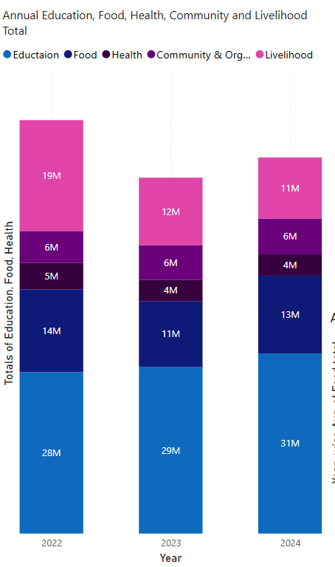

* The provided bar chart highlights annual expenditures across five distinct categories — Education, Food, Health, Community & Organization, and Livelihood for the years 2022, 2023, and 2024. Each bar is segmented to represent these categories using distinct colors for easy identification.
* **Key Insights:**
* **2022**:
* **Education** contributes **26M**, forming a major portion of the total expenditure.
* **Food** accounts for **14M**, while **Livelihood** follows closely at **19M**.
* **Health** and **Community & Organization** incur smaller costs of **6M** and **5M**, respectively.
* **2023**:
* **Education** expenditure increases to **29M**, showcasing a focus on this domain.
* **Food** costs dip to **11M**, marking a notable reduction.
* **Livelihood** costs decline to **12M**, while **Health** and **Community & Organization** maintain relatively consistent values at **4M** and **6M**.
* **2024**:
* **Education** expenses rise further to **31M**, indicating its growing importance over the three years.
* **Food** costs increase slightly to **13M**.
* **Livelihood** sees another decrease, falling to **11M**, while **Health** and **Community & Organization** expenditures remain stable.
* **Observations:**
* **Education** consistently shows a growth trend, emphasizing its priority across the years.
* **Livelihood** demonstrates a declining trajectory, which may warrant further investigation into underlying causes or shifts in funding allocation.
* **Health** and **Community & Organization** expenditures remain steady, indicating stable investment in these areas.
* **Pie Chart (Average Education Total by Year):**

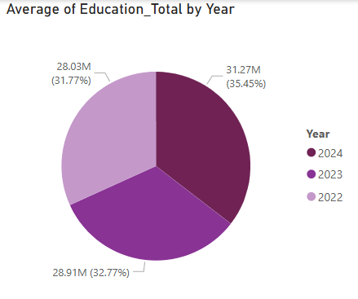

* This pie chart, presents the average total figures related to education expenses for three consecutive years: 2022, 2023, and 2024. Each year is represented as a distinct segment of the chart, color-coded for clarity, and their proportions are shown as percentages of the overall total.
* **Key Insights:**
* **2022**: The light purple segment represents this year, showing an average education total of **28.03M**, accounting for **31.77%** of the overall total. This indicates that education spending was relatively significant but not the highest among the years shown.
* **2023**: The purple segment signifies this year, with an average education total of **28.91M**, contributing to **32.77%** of the total. This suggests a slight increase in education expenditure compared to 2022.
* **2024**: The dark purple segment corresponds to this year, showing an average education total of **31.27M**, making up **35.45%** of the overall total. The consistent rise in spending points to an ongoing prioritization of education funding over these years.
* **Observations:**

The pie chart demonstrates a steady upward trend in education-related expenses, with each successive year accounting for a larger share of the total. This could indicate increased funding allocations towards educational initiatives or programs over time. A deeper analysis could explore potential drivers behind these increases, such as policy changes, inflation adjustments, or enhanced focus on education's role in broader societal growth.

* **Line Chart (Food Total by Year):**

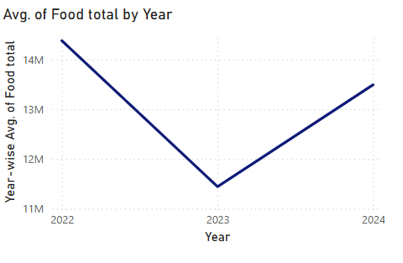

* This line chart, illustrates the year-wise average food expenditure from 2022 to 2024. It highlights trends in cost fluctuations over time, with the y-axis representing the average food total in millions (ranging from 11M to 14M) and the x-axis displaying the three years.
* **Key Observations:**
* **2022**: The average food total starts at approximately **14M**, indicating relatively high expenditure compared to the following years.
* **2023**: A significant decline is observed, with the average food total dropping to roughly **12M**, reflecting either a shift in spending priorities, cost optimization efforts, or external factors impacting food expenses.
* **2024**: The chart shows a rebound, as the average food total increases to approximately **13M**, suggesting a partial recovery in spending.
* **Trend Analysis:**
* The pattern depicted in the chart indicates a **U-shaped trajectory**, with food expenditure decreasing in 2023 before recovering in 2024.
* **Area Chart (Livelihood Total by Year):**

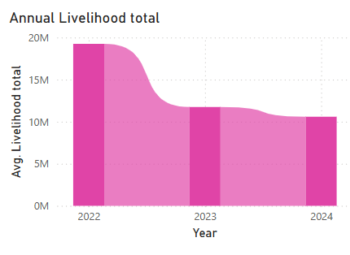

* The bar chart illustrates the average livelihood costs across three consecutive years: 2022, 2023, and 2024. The y-axis represents the average livelihood total in millions, ranging from **0M** to **20M**, while the x-axis marks the years.
* **Analytical Insights:**
* **2022**: This year records the **highest average livelihood total**, nearly reaching **20M**, suggesting significant investment or expenditure in livelihood-related initiatives.
* **2023**: A sharp decline is observed, with the average livelihood total dropping to approximately **10M**, which may indicate a shift in priorities, external economic factors, or adjustments in budget allocation.
* **2024**: The average livelihood total remains relatively stable, staying slightly below **10M**, hinting at a period of consistency following the 2023 decrease.
* **Observations:**

This chart reflects a clear downward trend between 2022 and 2023, followed by stabilization in 2024. The significant reduction in livelihood costs warrants further investigation into its underlying causes whether due to external influences, such as policy changes or economic shifts, or internal factors like organizational adjustments.

* **Clustered Column Chart (Health – Community & Org. Total):**

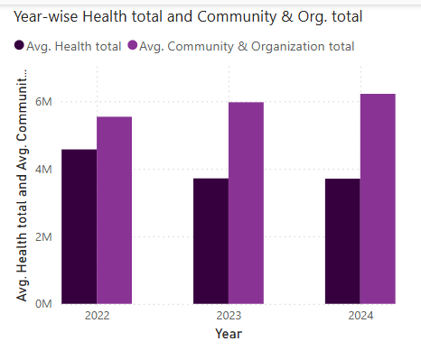

This bar chart, compares average yearly costs for two categories **Health Total** and **Community & Organization Total** over the years 2022, 2023, and 2024. Different shades of purple are used to visually distinguish between these categories, with darker purple representing Health Total and lighter purple representing Community & Organization Total.

**Analytical Insights:**

1. **2022**:
   * The average Health Total is approximately **4 million**, while the Community & Organization Total stands slightly higher at around **5 million**.
   * This indicates a modest initial investment in both sectors.
2. **2023**:
   * Both categories exhibit growth, with Health Total increasing to about **5 million** and Community & Organization Total rising to nearly **6 million**.
   * The consistent upward trend suggests enhanced focus or expanded initiatives in these areas.
3. **2024**:
   * Health Total remains stable at approximately **5 million**, while Community & Organization Total continues its upward trajectory, reaching around **6.5 million**.
   * The growing expenditure in Community & Organization Total may indicate a prioritization of community-driven programs and organizational development.

* **Observations:**

The chart reveals steady growth in both categories over time, with Community & Organization Total consistently surpassing Health Total in each year. This trend could be indicative of a strategic focus on community-oriented initiatives.

**Conclusion**

**Conclusion**

The dashboard follows best practices in data visualization and storytelling, ensuring that stakeholders can quickly interpret cost trends and category-based allocations. The analysis reveals that education receives the highest allocation among categories. However, food-related spending showed a dip in 2023 before recovering in 2024. The livelihood category saw a downward trend in expenditure, indicating a potential shift in funding priorities.   
By visualizing expenditures across categories, this dashboard helps stakeholders identify funding priorities, adjust budgets, and optimize resource allocation for maximum impact.

**References**  
Few, S. (2017). *Data visualization for success: A practical guide to telling compelling data stories.* Analytics Press.  
Tufte, E. R. (2001). *The visual display of quantitative information.* Graphics Press.  
Cairo, A. (2019). *How charts lie: Getting smarter about visual information.* W. W. Norton & Company.